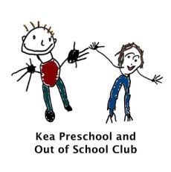
How we use the EYFS at Kea Preschool.

All children are different. They have their own unique experiences they bring to the setting. For example, their family and home life, cultures, experiences and interests. When creating and providing the learning environment, these factors need to be considered as every child is an individual. At Kea Preschool we believe all children learn through play and as a team of practitioners, we facilitate and extend their learning, allowing ALL children to reach their full potential.
All

Characteristics of Effective Learning.
Children need motivation to learn. Motivation is more important than intelligence and is the key to success for children and adults. The Characteristics of Effective Learning instil motivation to not only succeed in Early Years, but to also allow children to become lifelong learners. Integrating the Characteristics of Effective Learning at Kea Preschool is about how, we as practitioners provide an environment which ensures these different types of learning occur. When the characteristics are present, solid learning is taking place. Without the characteristics of effective learning, the children will not develop in the areas of learning. Therefore, the Characteristics of Effective Learning are not only statutory, they are essential.
Three characteristics of effective teaching and learning are:
- playing and exploring - children investigate and experience things, and ‘have a go’
- active learning - children concentrate and keep on trying if they encounter difficulties, and enjoy achievements
- creating and thinking critically - children have and develop their own ideas, make links between ideas, and develop strategies for doing things’

Our Pedagogy at Kea Preschool.
Pedagogy is a mixture of different approaches to teaching. Children learn through play, by adults modelling behaviour, by observing one another and through guided learning and direct teaching. At Kea Preschool, we ensure we use of variety of teaching methods in order for children to learn and develop using the most effective method for that child. This may be in the moment or planned activities. Every Key person knows their key children and plans and provides their next steps through observations.

