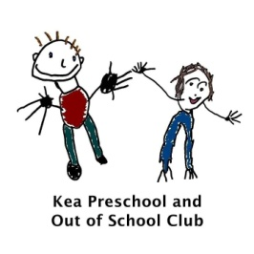
6.7 Oral health
The setting provides care for children and promotes health through promoting oral health and hygiene, encouraging healthy eating and healthy snacks.
- Fresh drinking water is available at all times and easily accessible.
- Sugary drinks are not served.
- Only water and milk are served with morning and afternoon snacks.
- Children are offered healthy nutritious snacks with no added sugar.
- Parents are discouraged from sending in confectionary as a snack or treat.

- Children are encouraged to brush their teeth as part of their daily routine and staff reinforce this through discussions with parents and children
- We have an Information pack that is distributed to all parents when their child starts the setting.
- Oral hygiene activities are included in planning to promote good oral health to all children.
- The setting co-ordinates with local oral health and ensure procedures are reviewed regularly, additional guidance from the local team may be added to this procedure.
Further guidance
Infant & Toddler Forum: Ten Steps for Healthy Toddlers www.infantandtoddlerforum.org/toddlers-to-preschool/healthy-eating/ten-steps-for-healthy-toddlers/

This policy was adopted by | Kea Preschool Ltd | (name of provider)
On | September 2021 | (date)
Reviewed  Date to be reviewed | 23rd October 2022  October 2023 | (date)
Signed on behalf of the provider | TMKEMP
Name of signatory | Tracey Kemp
Role of signatory (e.g. chair, director or owner) | Manager

