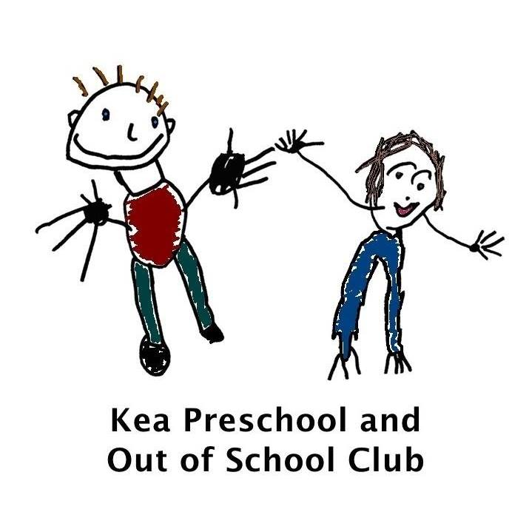
Record keeping procedure

Aim
We have record keeping systems in place for the safe and efficient management of the provision and to meet the needs of the children; that meet legal requirements for the storing and sharing of information within the framework of the GDPR and the Human Rights Act.

Objectives
- Children’s records are kept in personal files, divided into appropriate sections, and stored separately from their developmental records, or are kept electronically on management software systems.
- Children’s personal files contain registration information.
- Children’s personal files contain other material described as confidential as required, such as Common Assessment Framework assessments, Early Support information or Education, Health and Care Plan (EHCP, case notes including recording of concerns, discussions with parents/carers, and action taken, copies of correspondence and reports from other agencies.
- Ethnicity data is only recorded where parents/carers have identified the ethnicity of their child themselves.
- Confidentiality is maintained by secure storage of files in a locked cabinet with access restricted to those who need to know.
- Staff know how and when to share information effectively if they believe a family may require a particular service to achieve positive outcomes
- Staff know how to share information if they believe a child is in need or at risk of suffering harm.
- Staff record when and to whom information has been shared, why information was shared and whether consent was given. Where consent has not been given and staff have taken the decision, in line with guidelines, to override the refusal for consent, the decision to do so is recorded.
- Guidance and training for staff specifically covers the sharing of information between professions, organisations, and agencies as well as within them, and arrangements for training takes account of the value of multi-agency as well as single agency working.

Records
The following information and documentation are also held:
- name, address and contact details of the provider and all staff employed on the premises
- name address and contact details of any other person who will regularly be in unsupervised contact with children
- a daily record of all children looked after on the premises, their hours of attendance and their named key person
- certificate of registration displayed and shown to parents on request
- records of risk assessments
- record of complaints
Legal references
General Data Protection Regulation 2018
Freedom of Information Act 2000
Human Rights Act 1998
Statutory Framework for the Early Years Foundation Stage (DfE 2025)
Data Protection Act 2018

Further guidance
Information Sharing: Advice for practitioners providing safeguarding services to children, young people, parents and carers (HMG 2018 updated May 2024)
Business management mini-guide (Alliance publication)
Archiving children’s files
- Paper documents are removed from the child’s file, taken out of plastic pockets and placed in a robust envelope, with the child’s name and date of birth on the front and the date they left.
- The designated person writes clearly on the front of the envelope the length of time the file should be kept before destruction.
This is sealed and placed in an archive box and stored in a safe place i.e. A locked cabinet for three years or until the next Ofsted inspection conducted after the child has left the setting, and can then be destroyed.
- For web-based or electronic children’s files, the designated person must also use the archiving procedure, and records details of what needs to be retained/destroyed. The designated person must make arrangements to ensure that electronic files are deleted/retained as required in accordance with the required retention periods in the same way as paper-based files.
- Health and safety records and some accident records pertaining to a child are stored in line with required retention periods.

This policy was adopted by | Kea Preschool Ltd
On | March 2020 Previous Manager reviewed TK October 2021  reviewed 25th October 2023  30th October 2024  2nd October 2025
Date to be reviewed | Annually
Signed on behalf of the provider | TKEMP
Name of signatory | Tracey Kemp
Role of signatory (e.g. chair, director or owner) | Manager

