Transition Policy
Policy Statement
Kea Preschool is committed to positive transition experiences for children from starting preschool, moving from room to room and going to Primary school. Children are encouraged and coached through change to ensure that they are comfortable and confident to go through transitions.
Starting Kea Preschool
We aim to work with parents to support children through change and transition. When thinking of starting your child’s learning with us we will invite you for a look around the setting for you to meet the team, ask questions and allow your child to explore the environment for the first time with the comfort of a parent. Following a show around, if you choose to send your child to Kea Preschool, you will be given an Application to join form to complete with details about your child and what sessions you would require. Once the preschool received this, you will then be sent a registration form alongside all other relevant forms (photo consent, terms and conditions, forest school permission and medical letter). Once the child registration is completed and returned the preschool will be in touch to confirm when ‘Settling Sessions’ will take place. This is where your child can come into the setting for three sessions (building from half an hour to a morning) free of charge to become familiar with the setting and the key persons before they start their formal sessions. We recommend that before these sessions you talk to your child about what will happen and that you may be leaving them but will collect them again when they have played. We believe that parents are so important during transitions and we welcome parents to stay as much as required to support their child. It is so important that the child feels happy and safe at Kea Preschool. During the first settling session, parents are asked to stay and at this point parents are asked to complete an All About me page on the child’s tapestry account. This will give the preschool, and the child’s future key person vital information about what they like and will support the transition into nursery.
If after the initial first three settling sessions’ children require more support, the preschool works with parents to decide on the best way to support the child. The child comes first!
Transitioning between play rooms
As your child learns and grows, they will move between rooms (Toddler room to preschool room) as they get older. We work hard to ensure children are familiar with both rooms and our younger children join with our older children every afternoon. By doing so, this also gives children an opportunity to get to know key persons in each room. When your child is ready to move up to the preschool room, we will invite you in for a transition meeting where you will have a discussion with your child’s current key person and your child’s proposed new key person. This will give you an opportunity to discuss any worries or concerns you and your child have about moving to the next room and will allow you to meet the new key person. During the discussion staff will discuss transition sessions where your child will move to their new room. Parents will also be given a transition booklet that provides information about each room. Some children are confident to move straight away, and some children need a couple of sessions to settle in. It is important to remember that every child is different, and every child’s transition will be provided for with the child’s needs at the forefront and holistically. Children transition at different times and some children may move before their peers or after depending on their individual need. As a general rule, children move with their cohort at the following ages and in the term closest to their birthday;
Transitions to school
When the time comes for your child to go to Primary school we will ask you which Primary school your child will be attending. We will then contact the school with your permission to arrange for the reception class teacher to come into the setting to meet your child in an environment they are familiar with. We will speak to each school to find out transition session dates and discuss with reception teachers where each child is working within the EYFS and their next steps.
We incorporate school transitions into role play, circle time and activities to ensure discussions and interests in our new schools. We will support parents with school transitions and you will have a parents evening in the Spring/Summer term to discuss any issues or concerns regarding transitions. A school readiness pack will be worked on with your child through the summer term, where possible with input from new school. At Kea Preschool we prepare children for their new adventure in a healthy way:
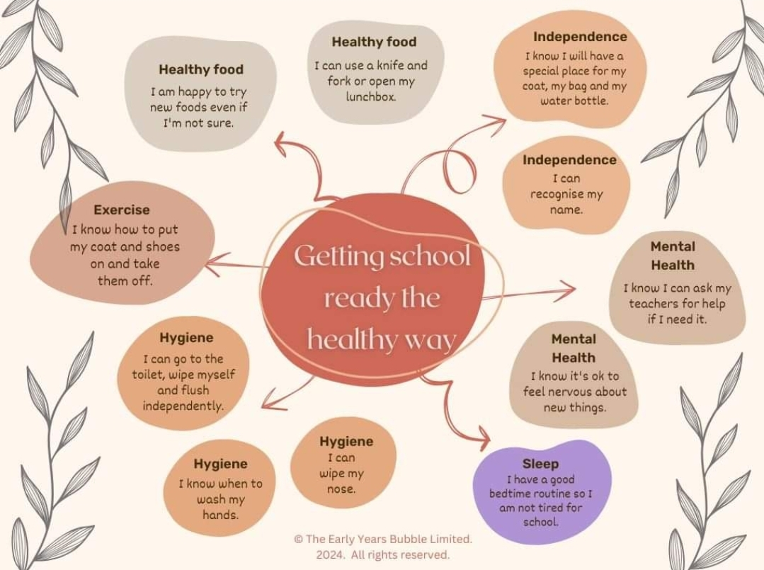
If you would like resources or more information on school readiness please see our website or speak to the nursery manager.

This policy was adopted by | Kea Preschool Ltd | (name of provider)
On | April 2021 | (date)reviewed  TK October 2021  TK April 2022  TK April 2023  TK April 2024  7th November 2024 (TK&MT)  2nd October 2025
Date to be reviewed | Annually
Signed on behalf of the provider | TMVERRAN
Name of signatory | Tracey Verran
Role of signatory (e.g. chair, director or owner) | Manager

