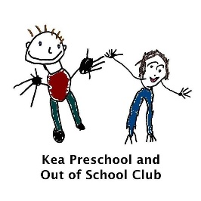
The Early Years Foundation Stage and curriculum at Kea Preschool
At Kea Preschool, we are legally required to comply with the Statutory Framework for the Early Years Foundation Stage 2026 and we endeavour to meet all these requirements.
Structure of the EYFS
Kea Preschool provides high-quality early education and care for children aged 20 months to 5 years in the preschool and for children aged 2–11 years within our wraparound care. Children may start from 20 months of age where the setting is able to meet their individual needs and it is in their best interests to do so.
At Kea Preschool we adhere to strict ratios of adults to children and this is as follows:
- At Kea Preschool we adhere to the statutory adult-to-child ratios within the EYFS. Our minimum staffing ratios are:
• Children aged 20 months to under 2 years – 1 adult to 3 children.
• 2-year-olds – 1 adult to 5 children.
• Children aged 3 years and over – 1 adult to 8 children (or 1:13 where the EYFS qualification requirements are met).
• Wraparound care is staffed in line with the ages, needs and number of children attending.
Kea Preschool may deploy higher staffing levels where required to meet children's individual needs, support SEND, maintain children's safety and wellbeing, and ensure high-quality interactions. Staffing is organised with consideration of the youngest children present and robust risk assessments.
- 3 and 4 year olds – 1:8
- Breakfast and After School Club –1:5 for 2 year olds and 1:8 for 3 and 4 year olds and 1:10 for school children.
Children may attend for 1 or more sessions a week and choose sessions that are suitable for their child. We accept both 15 and 30 hour funding.
Curriculum
Our curriculum has been revised in line with the new EYFS 2025. We adhere to the statutory framework for the EYFS - early-years-foundation-stage-framework - Follow-Link (effective 1st September 2025)
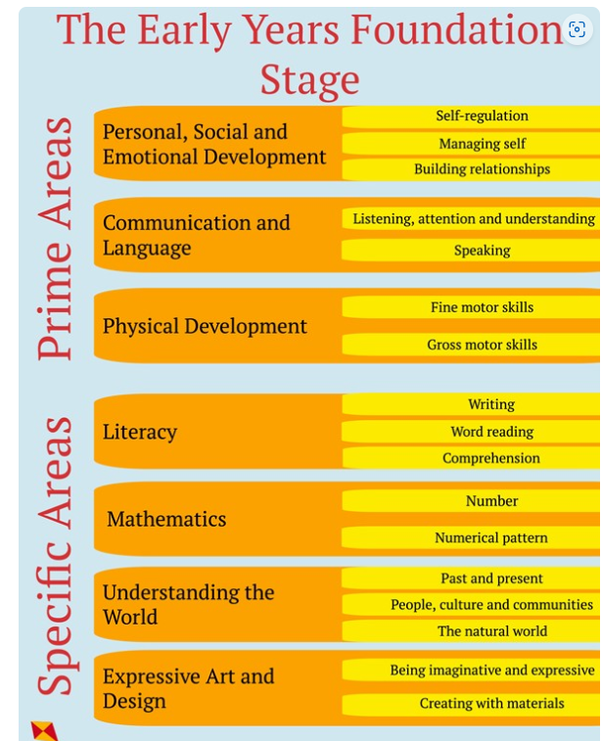
The setting uses supplementary materials to support our curriculum e.g. Development matters- Development_Matters_Report_and_illustrations_web__2_.pdf - - Follow-Link and birth to 5 matters - https://birthto5matters.org.uk
Intent
Being curious and playful is at the heart of what we do at Kea Preschool. Highly skilled staff ensure that all learning opportunities take place in a safe and nurturing learning environment that fosters the development of each child’s unique potential. We believe that all children have the right to shine! Within our rural, happy and enriching preschool, children can reach for the stars! It is our intent to support all children to become independent and collaborative learners and we encourage every child to be skilful communicators who are able to form connections with others through language and play.
At Kea Preschool, our aim is:
To provide high quality education and an environment which is happy, safe and secure, and which allows children to develop a love of learning.
To support children’s development of self-esteem, confidence, security and independence in order to promote their emotional wellbeing.
To encourage children to care for, enjoy and show interest in the world around them.
To work in partnership with parents and carers, creating a preschool which feels like a home from home, providing an extended family environment in order to ensure that every child can get the most benefit from their early years education and have the best start in life.
To support diversity and equality, welcoming all children and recognising that each child’s learning journey is individual and unique.
To equip our children with skills for learning, life and work, skills to be able to actively grasp, follow their dreams and reach for the stars!
Implementation
At Kea Preschool, we follow the Statutory Framework for the Early Years Foundation Stage. This framework sets the standards that must be met to ensure that children learn and develop well and are kept healthy and safe. It promotes teaching and learning to ensure children’s ‘school readiness’ and gives children the broad range of knowledge and skills that provide the right foundation for good future progress through life.
Our curriculum goals are planned considering children’s starting points and their interests and allows us to create challenging, meaningful and memorable experiences for every learner. Our curriculum is ambitious and is designed to give all children the knowledge, self-belief and cultural capital they need to succeed in life.
At Kea Preschool we allow children to lead their own learning through ‘In the Moment Planning’. Staff facilitate and extend children’s learning through observations and play. We value that every child is different, and all have different interests, and this is where our Key person system comes into effect. Key persons build up strong relationships and plan next steps for children around their interests. Staff ensure children learn whilst indoors and outdoors in our enriched environment.
There is a balance of child initiated and adult led learning. Adults are skilled at making learning explicit when children are following their own interests. ‘Teachable/wow moments’ are used with care in order to genuinely add to and be considerate of the child’s existing learning and experience We hold two Outdoor Learning sessions a week and we also have Sport 4 Tots come once a week.
We believe that the characteristics of effective learning are vital to success. Focussing on skills gives children the opportunity to learn in real life contexts and transfer their skills into different situations. Content or knowledge is important, but we believe children need the learning behaviours in order to access content and knowledge effectively.
Books as Hooks
We have selected our core books to encourage early reading skills, to foster a love of books, and to develop children’s communication and language skills.
We introduce one of our core stories every half term. Our ‘Core Books’ are picked purposefully for their varied themes and subjects. The books might include...
• One that has a good beginning, middle and end (traditional tale)
• A rhyming one (repeated refrains)
• One that reflects culture (diverse)
• A classic text
• One that draws out many different feelings (wellbeing/growth mind-set)
• And one of the rooms choice (miscellaneous)
Children are introduced to a new book each term (every 6 weeks). First, they read the story, often involving interactive props and resources that support the retelling of the story and add interest. As we continue to share the book with children, we can begin to add greater depth in our conversations, adding open ended questioning if suitable. Our older children will become more comfortable with the book, repeating phrases and remembering what happens next in the story.
We include characters, themes and ideas into the rest of our play – through using play dough, mark making, and using our outdoor space. We try and incorporate the book into the whole of the Learning Landscape so children can experience the story in different ways. This supports children to develop a deeper understanding and knowledge of the book. We have a designated area in both the Robins Room and Squirrels Room where staff display the book and have a range of activities for the children to explore.

If children are bilingual or have English as an Additional Language, we aim to share versions of these stories in their home language and English.
Partnership with Parents is an integral part of our core books and everything we do at Kea Preschool! We share what our core books are for each half term with parents on Tapestry, alongside activity ideas, new vocabulary, talking points, and links to a video so you can watch a reading of the book together using ‘Love My Books’. Welcome to lovemybooks! | lovemybooks
We value the impact that parents and carers have on their child’s learning. We aim to build strong, trusting relationships with parents and carers from the start.
The key person is responsible for being the advocate for the child and is the first point of contact for families. Building these strong relationships start right at the very beginning and our settling sessions which enables lots of interactions between staff and parents/carers.
We gain as much knowledge as we can about children before they start with us. We do this through ‘All About Me’ sheets/meetings and if required, home visits. We formally meet with families every term to share the children’s progress and achievement. However additional meetings may be required for some families.
We keep families in touch with the life of their child in preschool regularly through newsletters, Tapestry, photos, our website and social media and through everyday face to face contact.
Planning
At Kea Preschool we use children’s fascinations and interests to inform planning, as we know that children learn best when they are inspired and interested. Staff make observations which are recorded and may be acted upon immediately or may be addressed in future planning and this is all thorough ‘In The Moment’. Key persons know their key children and through observations and extending play opportunities in the moment they ensure children meet their next steps. Staff observe children carefully and listen to their ideas so that our curriculum reflects both their interests and their developmental needs.
Observations and Focus children
Staff observe children’s learning and development throughout the term, and will capture ‘wow moments’, however, each child will be a focus child for observations once every half term. This allows parents to have regular opportunities to contribute and consult with us. Staff will observe the focus children extra closely to monitor their interests, learning, development and progress. Our Two-year-olds and SEND children have 2 focus weeks a term. By the end of each child’s focus week, they will noticeably have more observations on Tapestry, where quality interactions and learning experiences are recorded.
At the end of the week, we will either catch up with parents for a quick chat or add a short summary observation to their Tapestry account.

All observations made of the children are based on quality interactions between children, or children and adults. Observations may include any teaching that has taken place or progress that a child, or group of children, have made or special ‘wow moments’ (see below for more details)
During interaction with children, emphasis is highly placed on using ‘I wonder…’ statements e.g., ‘I wonder if…’, ‘I wonder what…’, ‘I wonder how…’ etc. We feel this approach to questioning allows children to open up more readily, as opposed to direct, closed questions.
The average Early Years Practitioner may have a 1000 interactions and opportunities to plan in the moment each day, which potentially leads to 1000 tiny steps of development, all supporting the children to make progress over time.
It is impossible for us to record all of these interactions, and rather than attempt to document everything that happens we instead focus on writing less and interacting more.
To ensure that we are still documenting children’s progress and involving parents in their children’s learning we will be using the Focus Child approach as described above.

What are ‘wow moments’?
Within an enabling environment, and with supporting adults, children will learn how to do things independently and when such moments are observed they are referred to as ‘wow moments.’ Wow moments should focus on moments that are important for each child's personal growth and show off their own hard work.
Wow moments can be something a child does for the first time, skills they acquire, observations they make about the world around them and many other things.
They might have taken a big step forward, or we may celebrate a selection of little ones. Importantly, they shouldn't just be measured by what you expect for that child's age.
Wow moment examples:
(Child’s name) rode her bike around the garden for the first time without using stabilisers.
(Child’s name) put on her own shoes today.
(Child’s name) made a model of a rocket using kitchen roll tubes.
(Child’s name) was able to finish all the sentences with rhyming words in her bedtime story.
Any moment to celebrate!
Parents are encouraged to share observations of ‘wow moments’ of their child at home by making an observation on their child’s Tapestry account.
Impact
Evidence in children’s interactive learning journals on Tapestry captures learning across all areas of the EYFS curriculum. Our staff use observations to make assessments which inform future planning and ensure that all children build on their current knowledge and skills at an appropriate pace. 2-year-old checks are carried out as close to 30 months as possible for all children. We love our adults to be involved in genuine interactions with children so we ensure recording observations does not take time away from being with the children. Key workers are allocated to encourage a strong bond and deep knowledge of the children, enabling us to know the children well and know what they need to do next. This intrinsic knowledge is vital to supporting learning but does not always need to be recorded. We assess children against our curriculum goals and check that children are making progress appropriately. At Kea Preschool we use ‘The Doughnut Model’ to monitor progress monthly. Discussing achievement and progress with parents and carers is essential to understanding the holistic view of the child.
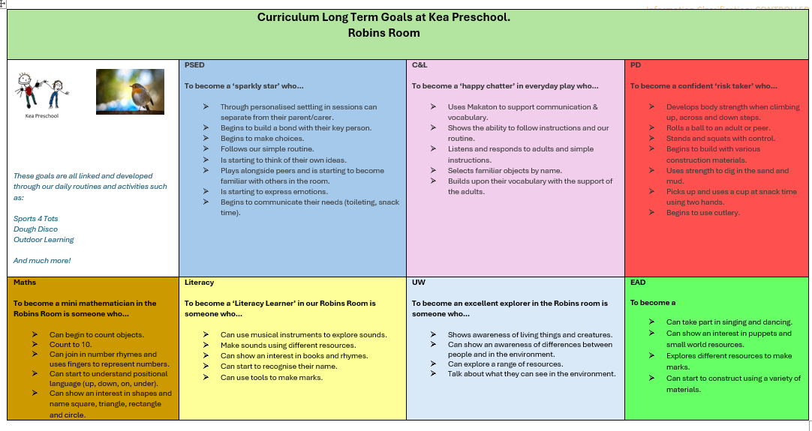

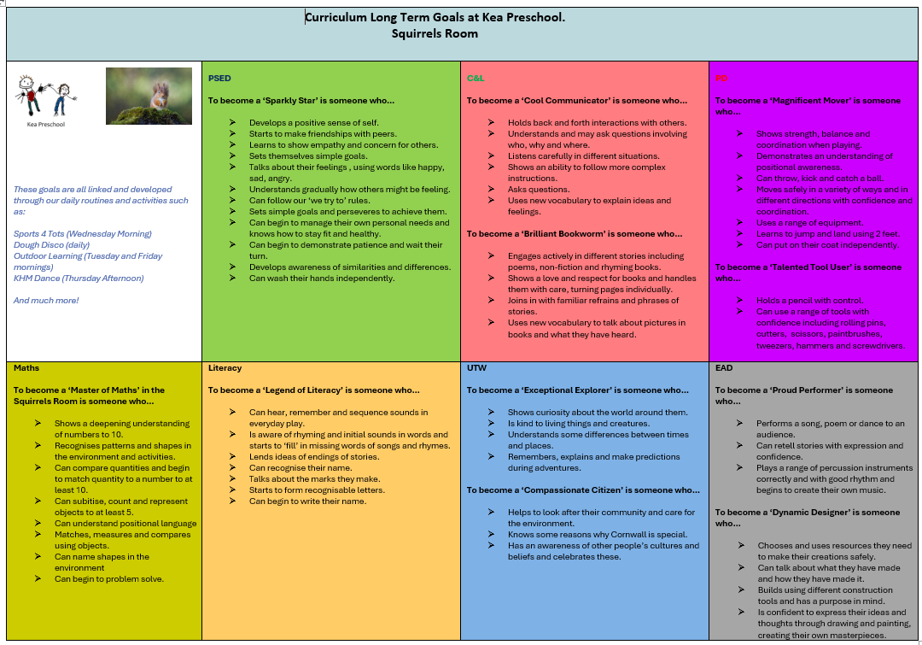

Cultural Capital at Kea Preschool.

At Kea Preschool, we believe that Cultural Capital is about giving our children the best possible start to their early education and future success.

It is our intention to provide a curriculum which enhances and broadens experiences and opportunities for all children, particularly for our most vulnerable young learners and to provide a culture of curiosity through magical moments: to widen horizons and tap into potential and instil ambition.

Our curriculum is pitched so that it offers a range of experiences which engage, enthuse and enlighten our children.

Adults at Kea Preschool have a wealth of experience which means high quality delivery of our intentions is possible and successful. This includes:
- forging strong relationships,
- working with other professionals,
- working with parents and the wider community,
- meeting children's needs, learning styles and interests,
- understanding the individual and diverse ways that children develop and learn,
- using staff knowledge and understanding in order to actively support and extend children’s learning in and across all seven areas of learning.

We regularly communicate with parents face to face but 'Tapestry', our online learning journal helps us to seek parent's opinions about their child and facilitate shared experiences.

We have always prepared our children (and families) for what comes next. We regularly receive positive feedback from parents and teachers about how our children are 'school ready' when they make the transition to primary school.

We will continually reflect on what we offer our young children to ensure that we remain focused in our ambition to give children the essential knowledge to be educated citizens and to open doors into worlds they didn't know existed.

This policy was adopted by | Kea Preschool Ltd
On | 29th September 2023  29th September 2024  30th October 2024  3/2/25  Reviewed 25th March 2025
Date to be reviewed | 30th September 2025  29th July 2026
Signed on behalf of the provider | TMVERRAN
Name of signatory | Tracey Verran
Role of signatory (e.g. chair, director or owner) | Manager

September 2026 Provision Update
From September 2026, Kea Preschool has reorganised its provision to better meet the needs of younger children and provide continuity of care. Robins Room is now open throughout the day. Children based in Robins Room remain in their familiar environment during the afternoon to promote secure attachments, emotional wellbeing and consistent key person relationships. Between 12:00 pm and 1:00 pm, children join The Squirrels Room for lunch before returning to Robins Room for the afternoon session.

The Squirrels Room continues to provide learning experiences for older preschool children and hosts the shared lunchtime period. Daily routines, staffing and transitions are carefully organised to ensure children experience high-quality interactions, age-appropriate learning opportunities and a calm, nurturing environment in line with the EYFS Statutory Framework 2026

