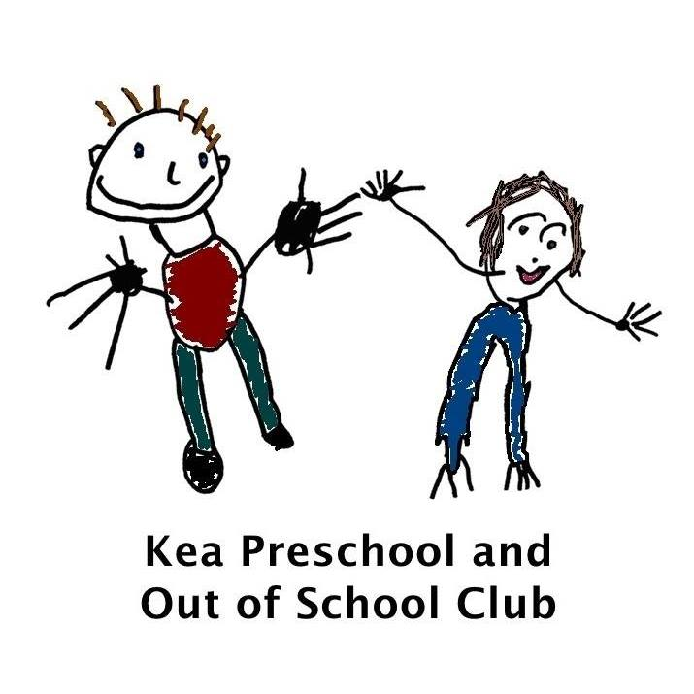

Staff Working With Their Own Children Policy

Kea Preschool is committed to providing a professional, inclusive and child-centred environment. Where staff choose to enrol their own child at the setting, the welfare and best interests of all children remain our priority.
Working Arrangements
Where possible, staff will not work directly in the same room as their own child. However, due to operational requirements, staffing ratios, room organisation or children's ages, this may not always be possible.
Where a staff member and their child are required to be in the same room, the management team will work collaboratively with the employee to identify strategies that support both the child and the member of staff. This may include adjustments to room deployment, routines, key person arrangements, transition support or other reasonable measures.
All staff are expected to maintain professional boundaries at all times. Staff must not be their own child's key person and must continue to meet the needs of their key children and fulfil all aspects of their job description.
When the Arrangement Is Not Working
If, despite appropriate support and reasonable adjustments, it becomes clear that the arrangement is having a significant impact on the child's wellbeing, emotional security, development, the staff member's ability to carry out their role, or the quality of provision for other children, the management team will arrange a supportive meeting with the staff member.
Together, all available options will be explored. Where it is agreed that the arrangement is no longer in the child's best interests, Kea Preschool will support the member of staff in exploring alternative childcare arrangements or another early year setting that is better able to meet the child's needs. These discussions will always be handled sensitively, respectfully and confidentially, with the child's welfare remaining the overriding consideration.
Equal Treatment
Children of employees will receive the same care, learning opportunities, expectations and professional standards as every other child attending preschool. No preferential treatment will be given to staff members or their children. Key persons will communicate with the child’s parent in the same manner they would with any other parent and offer a full hand over to the parent/ employee at the end of the child’s session if they are in a different room.
If a staff member’s child becomes unwell at preschool, the staff member must be conscious of the staffing ratios and seek permission to leave. They will possibly need to wait until appropriate cover can be found alternatively the second emergency contact should be contacted to help.

Safeguarding
All safeguarding concerns relating to a staff member's child will be managed in line with the setting's safeguarding policy. Where the child's parent is the Designated Safeguarding Lead, concerns must be reported to the Deputy Designated Safeguarding Lead.

Review: Annually or sooner if legislation or operational needs require.

Policy written:  2nd October 2025 Tracey Verran | Tracey Verran
Date: | 7th November 2024
Updated: | 31st July 2025  Tracey Verran
Reviewed: | 27th July 2026  Tracey Verran

