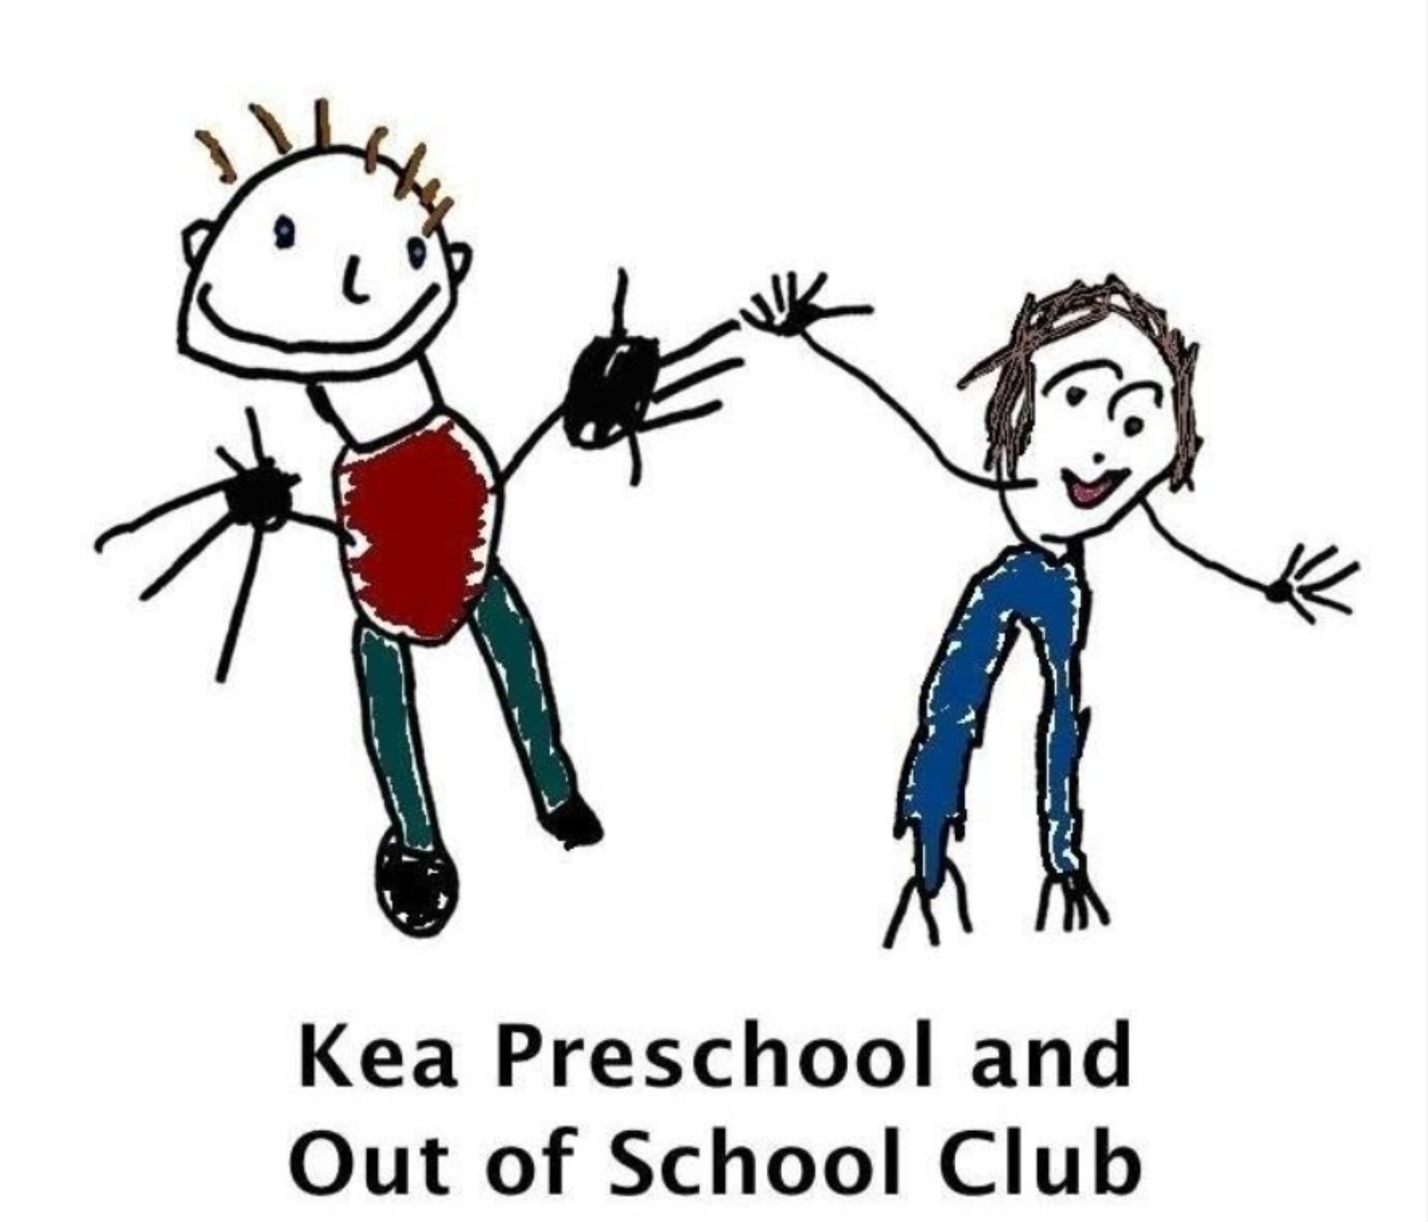

Wellbeing Days Policy for Staff
Kea Preschool and Out of School Club
Effective from: September 2026

Purpose
At Kea Preschool, we recognise the importance of supporting staff wellbeing and promoting a healthy work-life balance. To provide flexibility while ensuring the preschool can continue to operate safely and effectively, all staff are entitled to five unpaid Wellbeing Days per academic year. This policy replaces the previous unpaid leave arrangement.

Entitlement
Each member of staff is entitled to five unpaid Wellbeing Days per academic year.
- Taken as one block of consecutive working days.
- Taken as individual days throughout the academic year.
Unused Wellbeing Days cannot be carried forward to the next academic year.

Purpose of Wellbeing Days
- A holiday during term time.
- Celebrating a birthday.
- Attending a family event or special occasion.
- A wellbeing or mental health day.
- Personal appointments or commitments that cannot reasonably be arranged outside working hours.
This list is not exhaustive.

Requesting Wellbeing Days
- All requests must be submitted in writing to Melissa Thomas.
- Requests must be made at least one term in advance.
- Requests are subject to written management approval before any bookings are made.
- Approval depends on staffing levels, operational requirements, suitable cover and maintaining statutory adult-to-child ratios.

Arranging Cover
It is the responsibility of the member of staff requesting Wellbeing Day(s) to make every effort to arrange suitable cover before the request can be approved.
As Wellbeing Days are intended to support staff well-being, management will also assist staff in identifying suitable cover where possible. However, approval remains subject to appropriate cover being available, staffing levels, operational requirements and maintaining statutory adult-to-child ratios.

Payment
Wellbeing Days are unpaid. Staff who do not wish to lose pay may arrange to swap their working day(s) with another member of staff, subject to management approval. Any swap must ensure staffing levels, qualifications and ratios remain appropriate.

Short Notice Requests
Requests submitted with less than one term's notice will normally not be approved unless there are exceptional circumstances. Approval remains at the discretion of management.

Restrictions
- Suitable cover cannot be arranged.
- Safe staffing levels cannot be maintained.
- Statutory ratios would be compromised.
- Multiple members of staff have already been approved for leave on the same dates.
- Operational requirements or planned events mean leave cannot be accommodated.

Equality and Fairness
All requests will be considered fairly and consistently in line with this policy. Approval of previous requests does not guarantee approval of future requests. The preschool reserves the right to review or amend this policy to meet the operational needs of the setting.

Written By | Tracey Verran
Date | July 2026
Policy Owner | Manager
Approved By | Management Committee
Review Date | September 2027

